To: Rex Gatchalian – Department Secretary – Department of Social Welfare and Development

From: Anne Mercado – Department of Social Welfare and Development

Date: May 3, 2024

Re: Breaking the Cycle of Poverty in the Philippines
______________________________________________________________________

Executive Summary

Undoubtedly, the Philippines has been actively working to alleviate poverty for decades. Although the poverty rate has improved since 1985 (World Bank, 2022), there is a noticeable persistence in poverty concentration in urban areas. (Figure 1 in Appendix). This memo advocates for a decisive break in the cycle of poverty by recommending targeted investments in and enhancements to early childhood development programs within the poorest urban communities. This proposal aims to lay the foundation for long-term success by enhancing economic and social benefits. These include improving public goods and services, reducing crime rates, and expanding the pool of skilled workers. It calls for the implementation of both place-based and people-based policies in support of early childhood development programs specifically designed to uplift disadvantaged communities.
Background
The significant decline in poverty, falling by two-thirds, from 49.2 percent in 1985 to 16.7 in 2018 has been highly attributed to high growth rates and expansion of job agriculture (World Bank, 2022). Zooming into each respective region and urban area, the concentration of poverty has continued to persist and grow in the southern part of the country. (Figure 1 in Appendix) (Mcmangahas & Mcmangahas, 2018)

Problem Statement
While the Philippines has achieved a significant decline in poverty, progress has plateaued. With poverty incidence fluctuating between 16 and 25 percent over the past five years, (Philippines Statistics Authority, 2023) there is a pressing need to explore additional strategies. This raises the question: How can early childhood programs be strategically deployed to not only sustain but also further reduce poverty levels, particularly focusing on the most vulnerable populations in underserved communities?
Economic Argument for Early Childhood Programs
Harvard Magazine (2000) highlights the effectiveness of targeted, place-based interventions in alleviating localized distress, including programs focused on early childhood development. The article emphasized how policies directed at children have effects that are reaped over a longer period. The article mentioned the moving to opportunity (MTO) experiment. This specific study by Chetty et al., (2016) mentioned that the experiment has convincingly documented that early exposure to lower-poverty neighborhoods before the age of 13 experienced significantly improved long-term outcomes as adults.
Economic Argument against Early Childhood Programs
It’s a question of long-term payoff vs. immediate needs. The argument of prioritizing broad economic support for families—such as job creation and income support—could potentially offer more immediate and impactful benefits than early childhood programs. Ellen and Turner (1997) underscore that although neighborhood effects are significant, they are consistently much smaller than the effects of the familial connection. While early childhood programs are crucial, they do not directly address the more immediate economic drains caused by community violence and may not be the most cost-effective way to use limited resources aimed at poverty alleviation. (Sharkey et al., 2014)
Recommendations
Early childhood development programs extend beyond the educational aspect of a child's growth, striving for a holistic approach by incorporating diverse key components that together support a comprehensive developmental framework for children. The following are some of the recommendations. First, high-quality preschool education in disadvantaged communities ensures that all children regardless of their background have access to quality early education. Second, enhancing parental involvement in these programs. This means offering parental classes, training, mental health support, and economic assistance to the family within early childhood centers. Third, looking into the safety components of the community of the early childhood center. As shown in the study by Sharkey, et al., exposure to violence significantly affects children’s academic performance. In providing a safe environment for the children, they can focus on learning and not be distracted by other stressors. These recommendations along with strengthened foundational public service and infrastructure such as health facilities, transportation to early childhood centers, and affordable housing programs.
Conclusion
Focused interventions addressing immediate economic needs have successfully reduced poverty incidence and alleviated poverty concentration across the country. To break through the current plateau and further improve the socio-economic conditions both in specific communities and nationwide, early childhood development emerges as one of the vital tools. By investing in early childhood programs, we can significantly advance poverty alleviation efforts and enhance the overall development of children, especially in high-poverty and disadvantaged areas. This strategic approach not only addresses short-term economic challenges but also lays a foundational pathway for long-term societal benefits.
Appendix
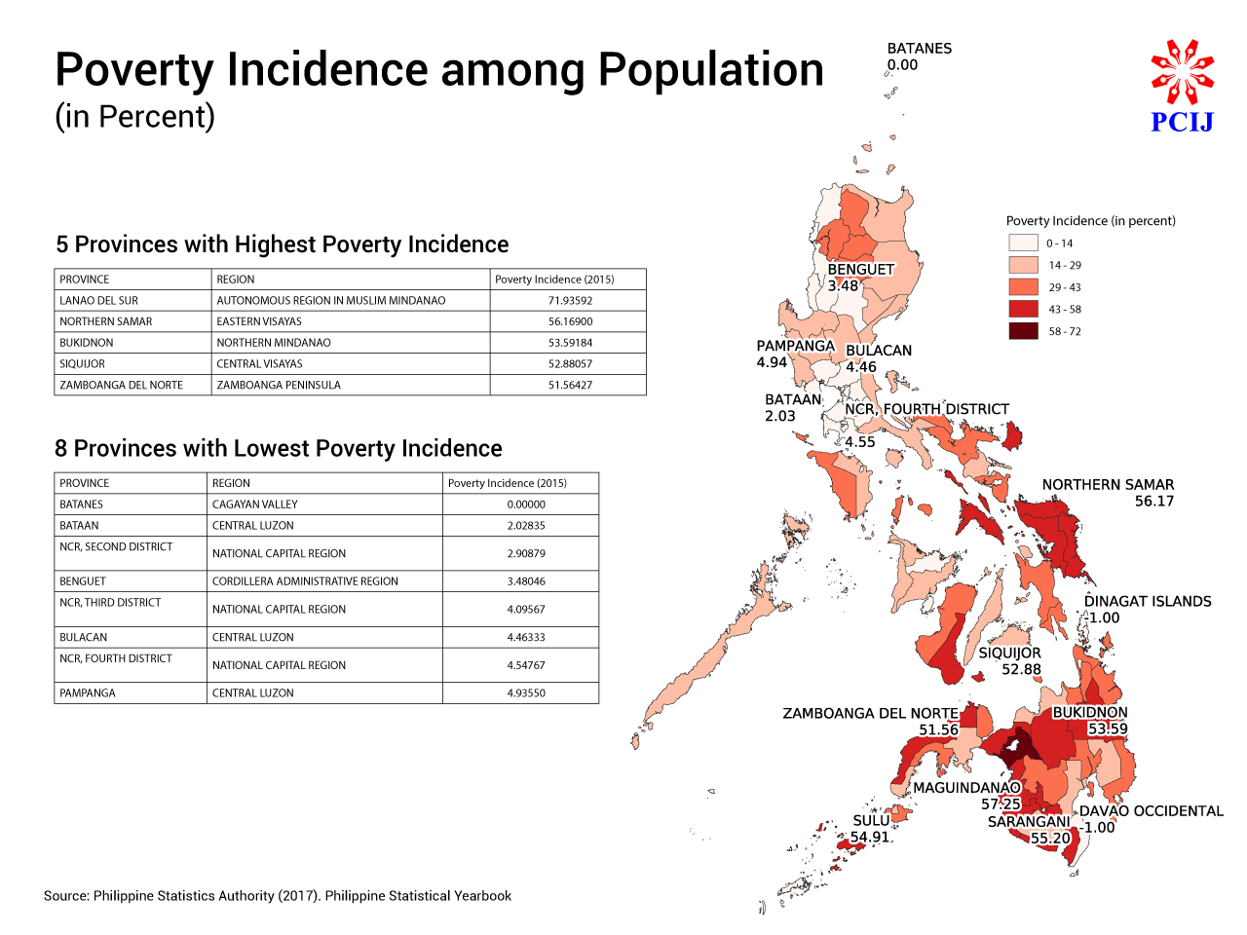
Source: Stats on the state of the regions: Hubs of wealth, ponds of poverty - Philippine Center for Investigative Journalism
Citation

  - PHILIPPINES: Reducing inequality key to becoming a Middle-Class society free of poverty. (2023, February 2). World Bank. https://www.worldbank.org/en/news/press-release/2022/11/24/ph-reducing-inequality-key-to-becoming-a-middle-class-society-free-of-poverty#:~:text=Driven%20by%20high%20growth%20rates,had%20risen%20to%2044%20million.
  - Philippine Statistics Authority. (n.d.). Highlights of the 2023 first semester official poverty statistics. Philippine Statistics Authority. https://psa.gov.ph/system/files/phdsd/Highlights of the 2023 1st sem Official Poverty Statistics.pdf
  - Statista. (2024, February 5). Poverty incidence among families Philippines 2021, by region. https://www.statista.com/statistics/1321332/philippines-poverty-incidence-of-families-by-region/
  - Poverty statistics | Philippine Statistics Authority | Republic of the Philippines. Philippine Statistics Authority. (n.d.-b). https://www.psa.gov.ph/statistics/poverty
  - Places, people, policies | Harvard Magazine. (2023, August 29). Harvard Magazine. https://www.harvardmagazine.com/2000/11/places-people-policies-html
  - Chetty, R., Hendren, N., & Katz, L. F. (2016). The Effects of Exposure to Better Neighborhoods on Children: New Evidence from the Moving to Opportunity Experiment. ˜the œAmerican Economic Review, 106(4), 855–902. https://doi.org/10.1257/aer.20150572
  - Ellen, I. G., & Turner, M. A. (1997). Does neighborhood matter? Assessing recent evidence. Housing Policy Debate, 8(4), 833–866. https://doi.org/10.1080/10511482.1997.9521280
  - Sharkey, Patrick, Amy Ellen Schwartz, Ingrid Gould Ellen, and Johanna Lacoe. 2014. “High stakes in the classroom, high stakes on the street: The effects of community violence on students’ standardized test performance.” Sociological Science 1: 199-220. DOI: 10.15195/v1.a14
  - Mcmangahas, & Mcmangahas. (2018, July 12). Stats on the state of the regions: Hubs of wealth, ponds of poverty - Philippine Center for Investigative Journalism. Philippine Center for Investigative Journalism -. https://old.pcij.org/stories/stats-on-the-state-of-the-regions-hubs-of-wealth-ponds-of-poverty/

